# User Experience

The website that was created is for all people within the Brisbane City Council area that have the need of wanting or needing to know where and which parks have Wi-Fi enabled for public use. The user could be of any age so the content must be all easy to read and to navigate. Our website achieves the web design principle of user experience by having the website to be easily navigateable with a constant navigation bar at the top allowing users to go back to the home page immediately or be taken straight to a page with a list of parks. If the user wants to they can also navigate the points on the map allowing the user to search by a series of fields of self-navigating. The content was structured around the users being able to get from the start to their required destination as easy as possible. Users can also register or login to the website and create reviews within the website at their favourite Wi-Fi parks that they have attended. User experience is mostly all about how easy it is for the user to navigate the website and easily find the information that they require, in this case how easy and accessible it is to find close Wi-Fi parks around the current user or the ability to search freely. Our website meets the principle by having an easy navigation allowing users to find their required information easily. The website also meets the principles by having a nice visual design and meets the rest of the standards which provides the overall user experience.

# Visual Design

The website reaches and matches the Web Design Principles by using the simple skills that are associated within Visual Design. Within visual design a colour scheme must be appealing and easy to look at so that way the audience can easily look at and understand the information displayed. The basic design for the website consists of a background image of the story bridge which is to show and fit the theme of the website being Brisbane City Council Wi-Fi Parks. The rest of the colour scheme is very basic and uses a “cool” blue and green as certain borders. When key information is displayed the colour scheme changes to simple black and white which allows the audience to read and understand the information easier. The fonts that are used within the website are the most common and basic fonts allowing the user to have easy readability of the information. If the font used was difficult to read it would then make the user experience harder to follow and understand the information being displayed.

# Page Layout

The layout that was chosen for the website was to have a background image that consisted and fit with the website. With the website it consists with a navigation bar that spans across the top of the page that features a logo in the top left corner and the navigation boxes to the right. This design was chosen due to the fact that people within the western culture focuses in on the top left corner and then follows to the right and then down accordingly. Due to this the layout features the navigation bar at the top followed by the information boxes bellow that are centred within the page and then ultimately the footer at the bottom of the page. The way in which the pages are laid out and designed allows the website to be aligned and not looking messy even with the size of the window being changed. The website has been designed with percentages to give appropriate sizing and spacing to all the boxes and information areas allowing in all space being utilised to give a clean look. The website that was created can be labelled as a centre fixed width page layout. The centre point is core with the website and depending on the page the information boxes move to keep the centre as the main point.

# Standards

Websites need to meet a set of standards otherwise when users come to use the website they will most likely turn away if they aren’t being met. The basic standards consist of the previous user experience, visual design and page layout can be seen as the core. Standards are within the website to allow the user the ability to navigate easily throughout while not looking like an eyesore. As mentioned through the previous principles, and within the photos. The information is displayed visibly while having the map within close vicinity allowing the user to determine the location as well.

The standards with the website follow HTML 5 and uses the appropriate CSS to make the website smooth and coherent. The website also uses tables when necessary to display data within the website and if not div’s are called upon to give the website structure within.

# Testing:

# Homepage

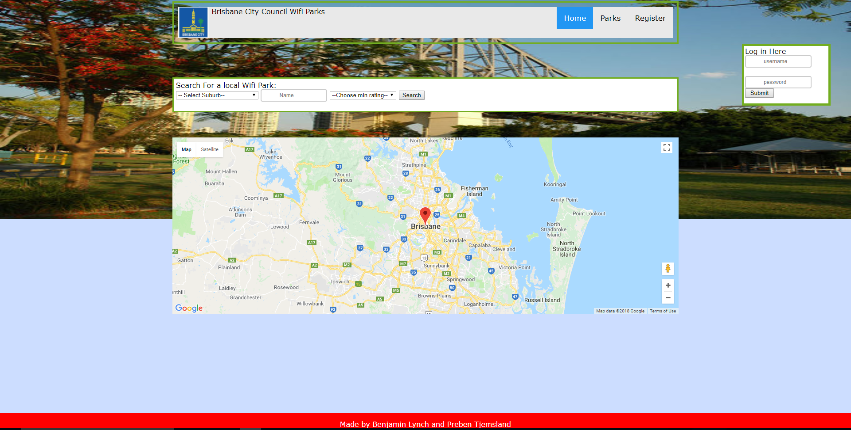

# Registering as a new user

(top nav bar is cut out so whole register form can be seen)

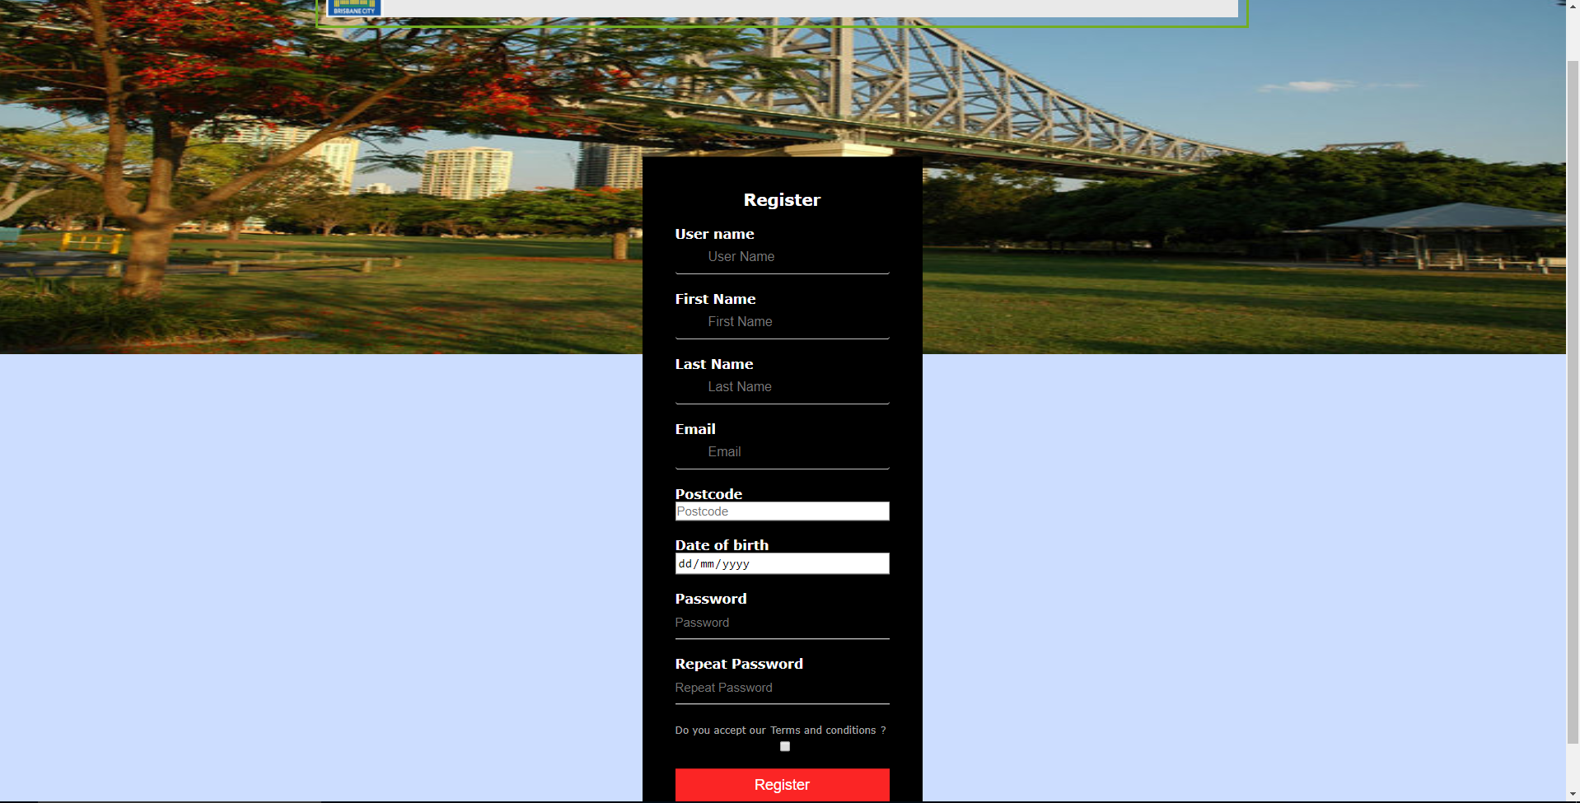

# Logging in with existing user

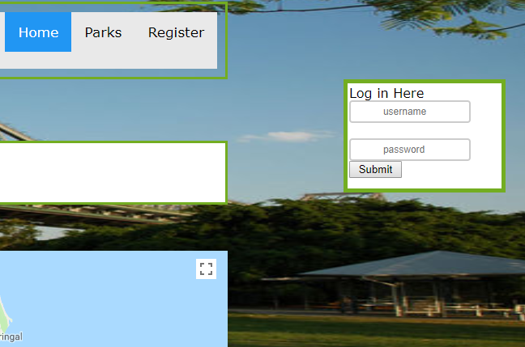

# Logging out

# Adding review

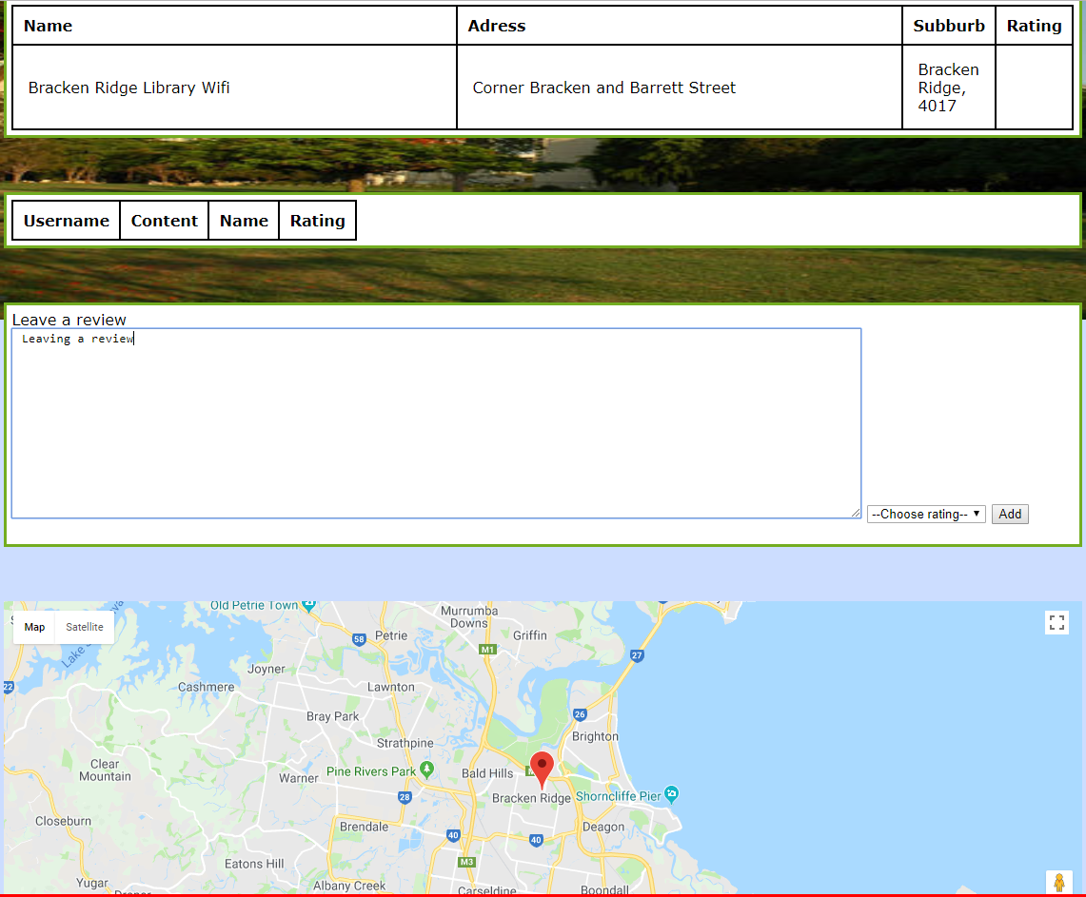

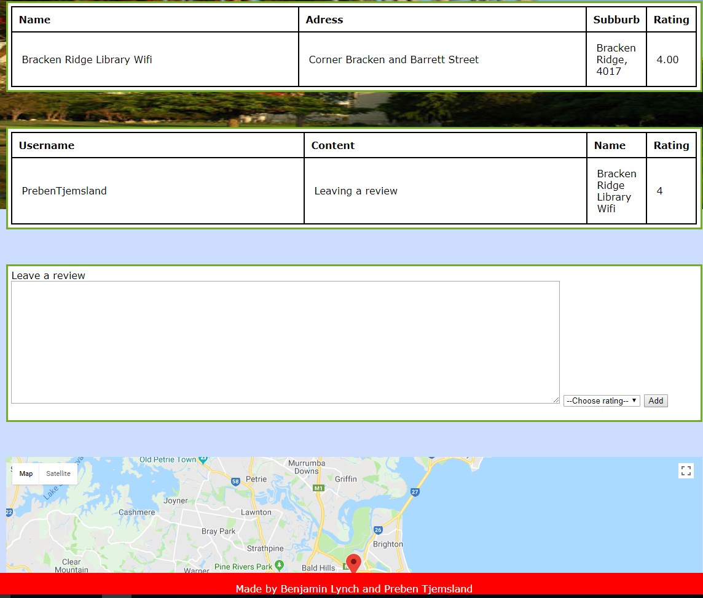

# Searching for item that exists

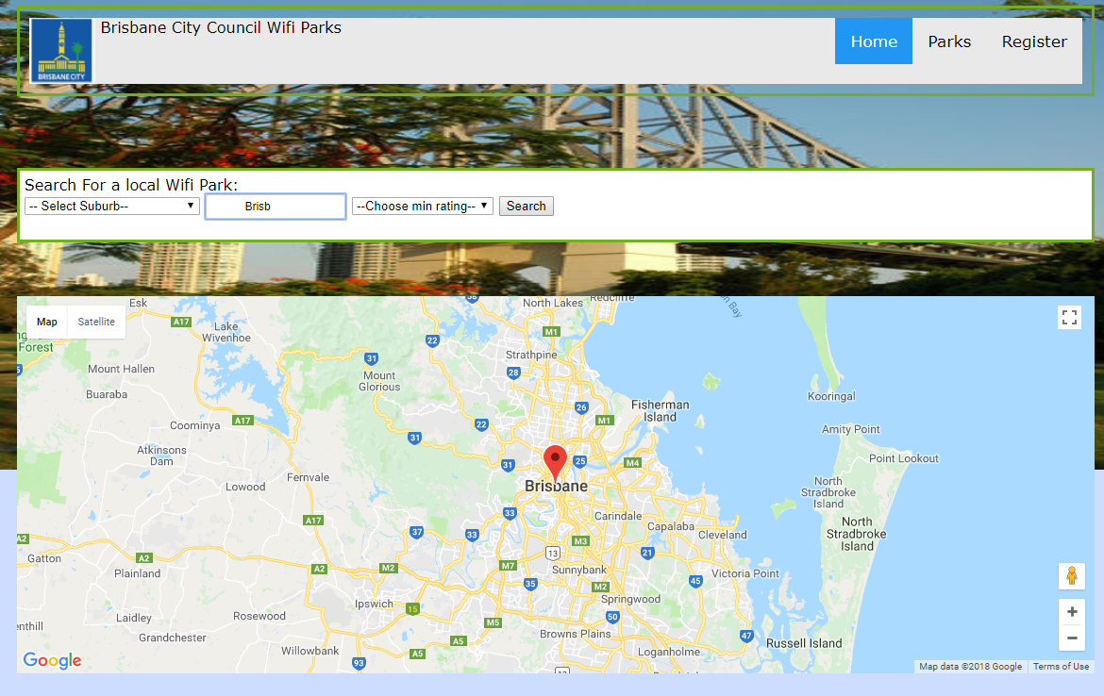

Needs markers

# Searching for item that doesn’t exist

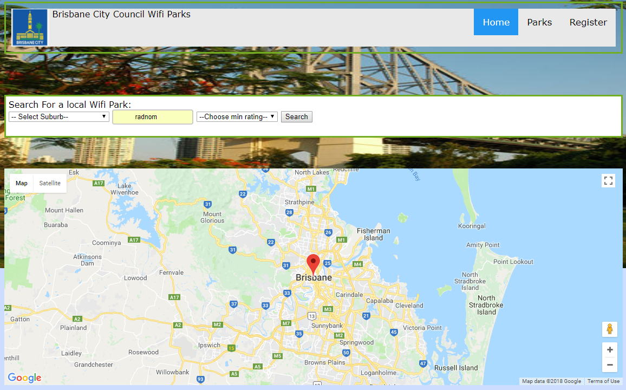

No information is displayed

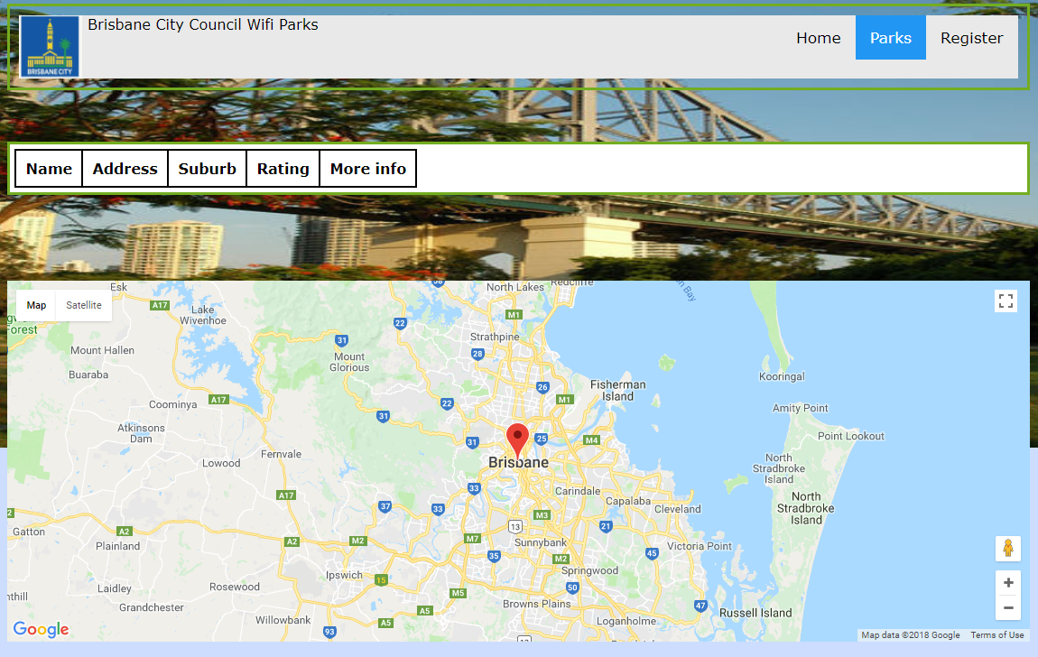

# Individual item page

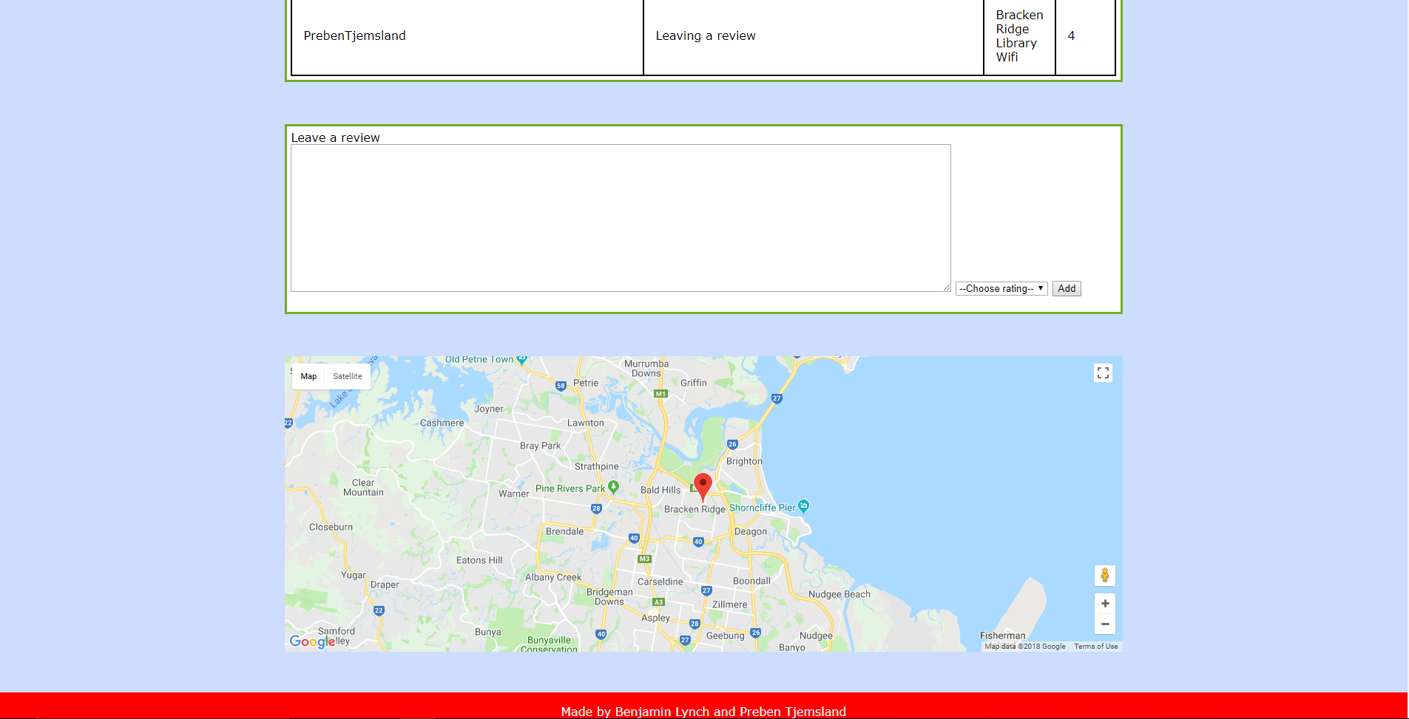

# User not being able to register due to invalid data

# Cross site scripting attack

# Sql attack

# User not being able to log in (unregistered)

# Evidence of site operating in multiple resolutions